## 20220816

https://www.cambly.com/api/chats/62fb85c1006d3e864c340418/video

<https://www.cambly.com/api/chats/62fb8a93edde6ce91d078589/video>

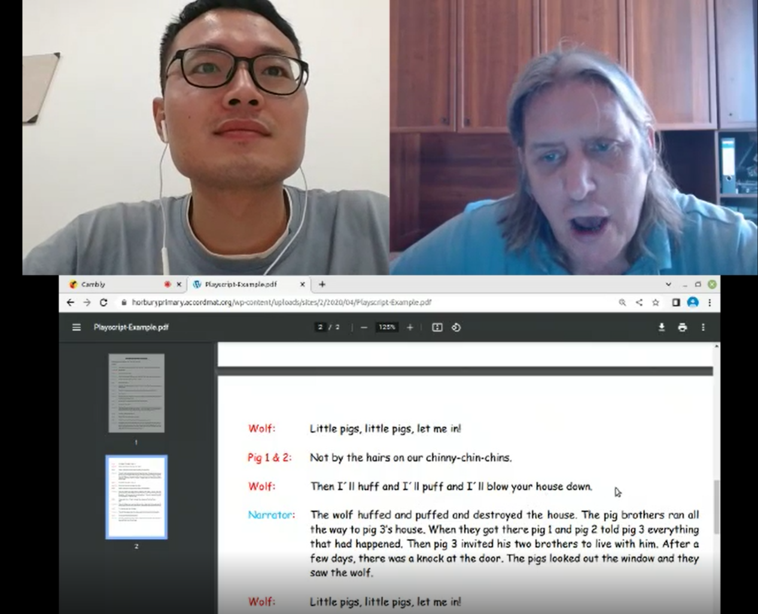

|  |  |
| --- | --- |
| Word | Pronounce / pho-ne-tic sym-bol |
| narrator | /nəˈreɪtə(r)/ 解说 |
| might, met,egg,sell | maɪt/  /met /sel/ |
| Knock  know | /nɒk/ kn |
| Puff  poof | pʌf/ 吹吸，抽（烟、烟斗等）；吹，喷 smoke  /pʊf/ 吹熄蜡烛的声音 |
| fair  fire | feə(r)/ 公平的  /ˈfaɪə(r) |
| peck  piper i e  pick  Peter  pickled | /pek/ 啄食  /ˈpaɪpə(r)/ 吹奏，胡椒 /pɪk/ 采摘 /ˈpiːtə(r)/  /ˈpɪkld/ pick lld |
| straw | /strɔː/ 干草 |
| Huff | 生气地说；把……吹胀，吹气；发 |
| Chimney  Roof / | tʃɪmni/ 烟筒  ruːf/ 屋顶 |

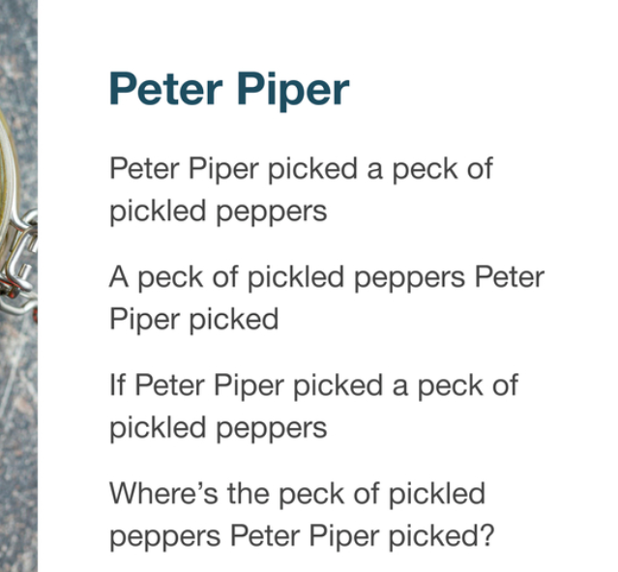

wolf and three pigs script

https://horburyprimary.accordmat.org/wp-content/uploads/sites/2/2020/04/Playscript-Example.pdf

